We have had such a crazy winter and the weather never seems to stop. At Care we have been trying to keep busy with activities, canceling and rescheduling. We have been playing BINGO, movie matinees, friendship club, Alzheimer’s and cardiac educational, and so much more. We are ever so grateful to everyone for their continued support of the program. It is so exciting to see it grow each year and to see the number of older adults we help remain in their homes increase. Please give the office a call if there is anything we can do for you, a neighbor, friend, or loved one. We are here to help! 320-857-2274. We have calendars, menus and more on the table outside the office. Feel free to come and pick up the monthly information.

Foot Care Clinic – 3rd Tuesday of each month.
Friendship Club – 2nd Thursday of each month.
Bone Builders – Monday and Thursdays 9:45am.
Walking – 8am – 3pm Monday – Friday.
Movie Nights – Check calendar.
Caregiver Support Group - 3rd Tuesday of the month
Grief Care Group - Last Monday of the month at 2pm. If you have lost a loved one and feel you need some support please join us in the dining room of South Grove. Sessions are led by Erin Riebe of Johnson Hagglund Funeral and Cremation.

Special thanks to all of the vendors and the community who came and made our Annual Health Expo a success! A thank you goes out to all of the volunteers who made and served the lunch and who worked at stations. We couldn’t do this without you!

History of the Auction – Rosie Dilley, Volunteer Coordinator, started the auction back in 2008 with a flatbed hay wagon selling all used items. They served ice cream cones in the back-parking lot in the heat of June. Slowly as the years progressed new donated items were put on the auction from community businesses. The auction slowly outgrew the parking lot and parking became a problem. The auction was moved to Trinity Lutheran Church in June of 2012 where it has stayed. Lunch started to be served and along came the root beer floats. In 2015 the Care Board decided to try hosting the Auction in April in hopes to avoid all the summer vacationers that are gone and attract more bidders. We now send to over 100 businesses and a lot of crafty friends for donation requests. I guess you can say we have grown over the years.
New volunteers are always needed to help us provide our services to are seniors. If you are interested in learning how you can become a volunteer who CARE’s for area seniors by using talents and skills you already have please give us a call at 320-857-2274.
We will work around your schedule and let you determine which services you are interested in providing. Email: gcacare@embarqmail.com
Please remember the Grove City Area Care Program when shopping year-round. Mother’s Day, Father’s Day, birthdays, Christmas, and everyday shopping.

*Funding of this program is made possible by the MN. Dept. of Human Services and by grants and contributions from private individuals, businesses and organizations. If you wish to contribute to the funding of this program through donations, bequests or memorials, please send your donation to the address listed. Thank You for your support.
(Donations are tax-deductible)
PO Box 192, Grove City, MN. 56243

Senior Dining
Senior Dining is every day Monday - Friday at South Grove Square Dining Room. This program is from Lutheran Social Service and is delivered hot for diners to enjoy. The meals are served at 11:30 am. If you are interested in coming, call the CARE office for details. We also have "home delivered meals" for those who are home bound and cannot get out to the meal site. This service is for 60 years and older.
Wintercade Grant was received for $500 to go towards $2.00 Tuesdays. Every Tuesday meals will be $2.00 until money runs out. Call the office to sign up! Give it a try! 857-2274
++++++++++++++++++++++++++++++++++++++++++++++++

Thank You for Your Support!
The CARE Program thanks you for all your donations these pasts months. October 2018 - March 2019
* Rosendale District 50 *Trinity Lutheran Women
*Trinity Church *Meeker County Warrant
* Trinity Missions BBQ *Medica
*Swede Grove Charities *Dayton Bus Service
*Wintercade *All Christmas Donations
*And all of the individual donations from our CARE Friends

*************************************************
Foot Care Clinic
The 3rd Tuesday from 8- 12 noon at South Grove
Prevention is the key!
Call the CARE office and schedule an appointment. A
Registered Nurse will be available to help care for your
feet. We would like to thank Beth Kern, RN for her years
of service.
Taking care of our feet is very important.
++++++++++++++++++++++++++++++++++++++++++++++++++

Spring Health Tips for Seniors

Most people, especially the elderly, tend to slow down during winter, so spring, when nature is waking up again, is the perfect time to get moving again. However, the most experts agree that being active all year round is the key to good health.
Bone Builders is a great way to get moving – please join us Monday and Thursday mornings at 9:45am to get stretching and moving at your own pace.
Walk around the gym as often as you would like!
April is National Volunteer Month
Congratulations to these people who were volunteer of the Month:
October 2018- March 2019
Oct. Donna Rueckert
Nov. Lucille Pautzke
Dec. Donna Rueckert – Volunteer of the Year
Jan. Bill and Ann Peterka
Feb. Becky Vann
Mar. Bob and Ruth Cordes
Thank you for the love you share for volunteering
++++++++++++++++++++++++
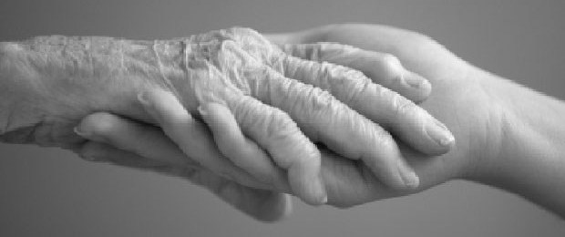
May is "Older American Month"
Pay tribute in some way to older adults in your community. Congratulate them on their accomplishments and let them know how special they are. Lend a hand or time to visit. Make a difference in someones life!
>>>>>>>>>>>>>>>>>>>>>>>>>

Handicap Equipment is available: walkers, wheelchairs, high rise toilet seats, canes, bath chairs, bath mats, bed assist bars, bed under pads, chair seat protectors, grabbers, grippers, long shoe horns, diabetic socks, bed alarm, sliding bath tub chair, get-u-up lift, pill cutter, pill boxes, foam tubes, and so much more! Stop in the office and check out the inventory - if we do not have what you are looking for, we will get it.
********************************************
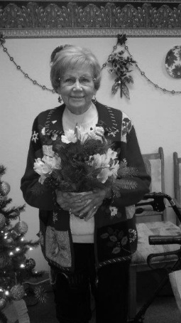
.
Volunteer of the Year:
Donna Rueckert
Donna is such a wonderful person. She volunteers in the Care office every Friday Morning and is always willing to bring food, work at the Health Expo, other events as well. She also calls in meals for senior dining. We can always count on Donna to be there to help us out!

